Abstract: 269/250 words
Manuscript: 2894/4000 words

Preventing Silent Errors in Clinical Data Analysis: A Novel Data Analysis Framework for Catching Errors in Human- and AI-Authored Code

Abstract

Objective
Mistakes in clinical and translational research data analytics are common, often challenging to identify, and lead to inaccurate outputs. Developing methods to minimize these errors is an established priority for clinical research. We designed and evaluated Baseline as an alternative to common Python and R data analysis libraries to address this gap.

Materials and Methods
Baseline is built in the TypeScript programming language and designed to preemptively identify potential errors by tracking how data types evolve throughout an analysis. Using 65 reproducible error scenarios across five categories, we evaluated how these errors are addressed in Baseline as well as two commonly used analytical frameworks in Python (pandas) and R (tidyverse) workflows. We also tested Baseline against an independent collection of 78 real-world data analysis bugs.

Results
Baseline caught 62 of 65 analytical errors before code execution and the remaining 3 when data was first loaded before further analysis. Conversely, pandas and tidyverse silently executed 39 (60%) and 32 (49.2%) of the 65 error scenarios, and permitted silent errors in 100% and 88% of scenarios involving missing data values, respectively. Baseline detected 78 real-world bugs from the external collection before code execution.
Discussion

This analysis demonstrates how data type errors in conventional clinical research workflows can lead to incorrect and often silent outputs. It highlights how a new method that tracks data types can prevent an important class of errors.

Conclusion
Baseline is a novel, open-source data analysis framework designed to prevent a pervasive class of silent errors in clinical data analysis. Baseline offers a guardrail that directly addresses a well-documented source of error in clinical and translational research.

Background and Significance
Whether for research studies, quality improvement, or clinical operations, clinical data analysis involves many individual data processing steps. A standard workflow might query patient data from a database or import it from a file, reorganize it, combine it with data from other sources, calculate new values, summarize the results, and run statistical tests.
While these steps are routine, they are also error-prone. Some errors may be small and benign, such as a typo when spelling the name of a file. Others can have consequences large enough to change study conclusions. One review of 884 retracted articles in clinical and translational research found that 28% described problems preparing or analyzing data.[1] Minimizing these types of errors has been identified as a priority for clinical research.[Sanchez et al. (2021)],[ Kennett et al. (2026)],[ Collins and Tabak (2014)]
Errors in analytical code can manifest in one of several ways. Some errors lead the code to halt as soon as the error is encountered. Some are more insidious, silently allowing code to run fully but corrupting results in ways that can be nuanced and hard to detect. These silent errors commonly involve issues related to the underlying type of data that code is trying to access or change. Researchers might be surprised to find that it is altogether an easy mistake to accidentally multiply a word by a number or combine two datasets in a way that silently drops hundreds of patients from a study.
Although these mistakes pose serious risks to clinical research, they stem from a broader challenge of code correctness across all of software development. This challenge is accelerating as analysts increasingly rely on artificial intelligence (AI) assistance for programming [Daniotti et al. (2026)], as AI-generated code often contains subtle logical flaws.[ Forero (2025)],[ Howell et al. (2024)] To minimize these errors the software industry has introduced safeguards like automated test suites, strict validation frameworks, and peer reviews.[ Vable et al. (2021)],[ Hunter-Zinck et al. (2021)] While these development practices can significantly reduce bugs, they cannot fully eliminate risks that are inherent to the design of the programming languages themselves.[Hodges et al. (2023)][ Bhandari Neupane et al. (2019)]
Most clinical data analysis is performed in dynamically typed languages like Python or R.[ Goldmann et al. (2025)],[Tazare et al. (2024)]. Both languages can surface errors during code execution, but these checks typically only confirm whether a given line of code can technically run with some data. There is no inherent mechanism for broadly enforcing that the data accessed when the code runs actually aligns with the data an analyst expected throughout an analytical pipeline. For example, in Python, the numeric value `1` and the boolean value “True” can be used interchangeably in many operations.[Python Software Foundation 2026] A string of characters, such as “MISSING”, can technically be multiplied by 2 and results in a value “MISSINGMISSING”. [Python Software Foundation 2026] As a result, logically incorrect operations may still execute successfully without warning and lead to downstream incorrect results.
In contrast, statically typed programming languages are designed to catch these kinds of silent errors before the code runs. They use a compiler to keep track of what kind of data each variable is expected to contain. Prior to running the code, the compiler can pre-emptively detect if there are operations that do not align with the expected data types. It does this by monitoring how operations, throughout a program, may change the data type or introduce missing values. This kind of pre-execution type check is known as compile-time checking, and its theoretical foundation is well established.[2][3] Empirical studies of static type systems in JavaScript and Python have shown that 11–18% of real-world bugs broadly across software projects would have been caught at compile time.[4][5]
Catching errors before any analytical code runs provides additional safeguards that are particularly relevant to clinical data processing. For complex research workflows, discovering an error hours into a computationally expensive analysis can waste valuable computational resources and delays results. Worse, if the error does not halt execution, the script may output a seemingly accurate but incorrect results. Furthermore, as analytical and predictive models are increasingly deployed directly into production through clinical decision support tools[Daly et al. (2026)][Lin et al. (2025)][Susanto et al. (2023)], the consequences of runtime errors can scale. An unexpected crash or a silent error might result in a partially updated database or an incorrect clinical alert being triggered before the issue is caught.
TypeScript is a programming language with compile-time type checking[Bierman et al. (2014)] that is already used in clinical informatics for health data standards, web dashboards, and data services.[6][7] Despite this adoption, TypeScript has not traditionally been used as a primary language for data analysis itself. Extending TypeScript to support data analysis offers a promising mechanism to reduce certain categories of analytical errors and support increasing regulatory expectations for formal evaluation of data quality in clinical software.[8][9]
We therefore evaluate whether Baseline, a novel alternative data analysis framework built in TypeScript designed to support common analytical workflows, can detect common data processing errors that would otherwise remain undetected in conventional Python and R workflows, and we characterize the practical limits of this approach.

Objective
The evaluation of Baseline addressed three primary questions:
- Can TypeScript's compile-time checking accurately track column names, data types, and missing values throughout standard clinical data processing steps to catch errors before code execution?
- How does error detection in Baseline compare to conventional analytical workflows in Python[Python Software Foundation 2026] (pandas)[McKinney 2009] and R[R Core Team (2026)] (tidyverse) [ Wickham et al. (2019)] when exposed to equivalent clinical data errors?
- What are the practical boundaries of compile-time checking, and under what conditions does runtime validation remain necessary?

Materials and Methods

System Design
Baseline is a TypeScript framework for working with datasets. It represents the dataset as a dataframe, with data structured as a table with a collection of rows and named columns. Each column contains a specific type of data – like a number, some text, a boolean True or False, an explicit absence of a value (null or undefined), and combinations therein. These data types are strictly tracked by Baseline. For the purposes of this study, the terms dataset and dataframe will be used interchangeably.
Compile-Time Checking
When a dataset is manipulated or edited, Baseline tracks how the type of data contained in columns may change. For example, when joining the columns of two datasets – for example, a patient demographics dataset and a patient lab results dataset – it is possible that some patients may not have both demographics and lab result data. As a result, they may potentially have missing values in one or more dataset columns. Baseline keeps track of this possibility, marking data values as possibly missing and requiring that code address potentially missing values explicitly.
This example is one specific case among a broad range of possible data changes that Baseline tracks. Each common dataset operation in Baseline follows defined rules that determine how the column data types may change. The full set of type rules covering all operations is provided in Supplementary Table 1.
When importing external data, such as from a database or from files like comma-separated values (CSV), XLSX, or Parquet, Baseline ensures that any imported data matches the expected data types prior to proceeding with built-in data validation checks.
System Validation
Baseline supports an array of common dataset operations, such as filtering, summarizing, modifying columns, and replacing missing values. It also provides functionalities to calculate descriptive statistics, hypothesis testing, and regression modeling. The accuracy of these operations, both related to tracking data types and the quantitative outputs, is validated by a suite of over 1,700 separate, reproducible, publicly-accessible tests. Functionalities for hypothesis testing and regression modeling are validated directly against R, with outputs aligning within a tolerance of 10⁻⁶.
The source code for Baseline and its extensive testing infrastructure, including automated scripts to run all internal framework tests, is publicly available for review [https://github.com/jtmenchaca/dbmi].
Figure 1 illustrates features of a data analysis workflow in Baseline.

Language Comparison Suite
To compare error detection across Baseline, Python, and R, we created a standalone, reproducible comparison suite of 65 common error scenarios for clinical data analysis. The test cases were derived from error patterns described in published clinical data quality literature[10][11][12][13][14] and from errors encountered during common data analysis tasks at the University of Utah.
Tests were organized into five common error categories for clinical data analysis: column reference errors, value type errors, missing value errors, dataset join errors, and dataset loading errors.
We implemented the error scenarios in Baseline, pandas (3.0.3)[McKinney 2009] with Python 3.14.5[Python Software Foundation 2026] and tidyverse (2.0.0)[ Wickham et al. (2019)] with R 4.6.0[R Core Team (2026)]. Baseline tests were run with TypeScript 5.9.2 on Deno 2.8.0, a runtime environment for TypeScript. The output of the error scenarios for each language were classified into one of four categories: compile-time error, error during execution, warning during execution, or silent continuation.
For completeness, the 65 error scenarios were also implemented in the Python Polars (1.30.0) data analysis library due to its increasing popularity, as well as with the mypy and pyright static type checking libraries intended to augment the base Python language and catch errors prior to code execution.
Pandas and tidyverse implementations used standard patterns from each library's official documentation, without supplemental runtime validation libraries like pandera or pointblank. This isolates the contribution of the language and core data analysis library and reflects the most common analyst workflow. Runtime validation libraries are discussed separately as a complementary approach.
The error scenarios were specified from published clinical data quality literature and observed errors at the University of Utah, with categories defined by clinical error type rather than by which language's mechanisms would detect them. Because the suite was authored by the same team that developed Baseline, we performed external validation against an independent bug collection to test whether the results generalize beyond scenarios of our own construction.
External Validation Against an Independent Bug Collection
We evaluated Baseline against a published collection of Python and R data analytics bugs.[15] The collection manually classified bugs from online forums and code repositories, labeling each bug by type, root cause, and effect. We selected the 164 bugs where the root cause of the failure was labeled as a Type Mismatch.
Among the Type Mismatch bugs, we excluded those with features that are inherently specific to a particular language or library, those arising outside tabular analysis workflow, and those caused by incorrect API usage rather than a type problem in the data. Each included bug is reproduced in a self-contained file that runs the original Python or R code alongside the equivalent Baseline implementation. For each bug, we also determined whether or not the original bug is reproducible in modern versions of Python and R libraries.

Results

Language Comparison Suite
The comparison suite included 65 tests across five error categories: 16 (25%) column reference errors, 14 (22%) value type errors, 17 (26%) missing value errors, 8 (12%) join errors, and 10 (15%) data loading errors. Each test was run in Baseline, pandas, and tidyverse.
Baseline caught 62 of 65 errors (95%) before code execution and intercepted the remaining 3 by halting execution when external data files were first loaded. Pandas halted execution for 26 (40%) and allowed silent continuation for 39 (60%). Tidyverse halted execution for 29 (45%), provided a text-based warning for 4 (6%), and allowed silent continuation for 32 (49%) (Table 1, Figure 2).
The Python static checking libraries mypy and pyright did not catch any of the 65 errors prior to code execution (Supplementary Table 2). The Polars data analysis library halted code execution for 28 of 65 errors (43%), performing comparably to pandas and tidyverse. Like pandas, Polars allowed silent continuation for all 17 missing value errors. Stricter Polars configurations, including explicit schemas and lazy evaluation, did not change this result.
If pre-execution checks were explicitly bypassed, Baseline halted code execution for 36 (55%) of the 65 errors.
The largest detection gap occurred with missing values, where pandas and tidyverse allowed 17 (100%) and 15 (88%) error scenarios to continue silently, respectively. In contrast, column reference errors, where a provided column name was misspelled or non-existent, showed the smallest detection gap, with pandas and tidyverse both halting execution for 14 of 16 (88%) scenarios.
External Validation Against an Independent Bug Collection
Of the 164 Type Mismatch bugs, 78 met the inclusion criteria of having a direct equivalent across programming languages applicable to general data analytics. Rationale for exclusion can be found in Supplemental Table 3, with the primary reason being that the bugs were related to code unrelated to tabular data analysis. Among the 78 included bugs, there were 60 (76%) data type errors, 9 (11%) missing value errors, 4 (5%) data loading errors, 4 (5%) column reference errors, and 1 (1%) dataset join error. All 78 bugs were caught by Baseline before code execution.
Of the 78 included bugs, 62 (80%) still trigger the original failure in current versions of the respective Python and R libraries. The remaining 16 no longer reproduce the original silent failure, reflecting upstream changes in those libraries since the bugs were originally reported.

Discussion
Both our publicly-available comparison suite and an external collection of real-world bugs illustrate how a novel compile-time safe data analytics library catches numerous silent errors that occur in two of the most commonly used programming languages for clinical data analysis. The gap was most prominent in cases where missing values might enter an analysis, potentially producing plausible but systematically incorrect output (Figure 3).
Python's optional static analysis tools did not address this limitation. Even with the most thorough settings enabled, mypy and pyright failed to detect any of the 65 errors. While these tools can describe the types of individual values, they do not integrate with pandas to track how dataset columns and missing values change throughout a data analysis. The increasingly popular Polars data analysis library for Python likewise did not meaningfully outperform pandas or tidyverse.
These findings are situated within a broader literature documenting the prevalence and consequences of analytical errors in clinical research. Broad analyses of thousands of retracted medical publications have found that data concerns were the single most common reason for retraction at 31.5%.[16] An earlier study of 395 retracted articles found that unintentional errors — mistakes in sampling, procedures, or data analysis — accounted for more than twice as many retractions as scientific misconduct.[17] A survey of 97 researchers whose papers were retracted due to unintentional errors found that inattention was the most frequently cited cause, and that errors could occur at any stage of the data management workflow.[18] Taken together, these findings suggest that a substantial share of retracted clinical research may stem from the kind of routine, silent processing errors that compile-time type systems are specifically designed to prevent.
As clinical research and informatics increasingly make use of AI-assisted programming, the risk of silent errors is magnified. AI outputs frequently hallucinate APIs and generate plausible but logically flawed code that languages like Python or R will execute without warning.[19] We anticipate that data analysis tools that incorporate pre-execution type checks like Baseline can serve as an important guardrail to permit AI agents to author increasingly complex, error-free clinical data analyses. Future work will assess the real-world utility of Baseline in this regard.
Baseline occupies a different domain of error prevention than existing tools that primarily evaluate the completeness, conformance, or plausibility of existing clinical data repositories, such as the OHDSI Data Quality Dashboard.[20] Data handling during analysis has been identified as a distinct source of error that these approaches do not address.[21][22] Baseline and compile-time data analytics help directly bridge this gap.
Runtime validation libraries in Python and R, such as pandera and pointblank, also target errors within the analysis workflow. These libraries can theoretically catch many of the errors that Baseline detects. However, they require analysts to anticipate each possible error and add checks manually. Baseline applies equivalent checks automatically through the compiler, whether or not the analyst anticipated the problem in advance. As such, we did not include these libraries in the comparison. The gap measured here reflects what conventional Python and R workflows catch by default, not what they can catch with additional tooling.
Limitations
While compile-time programming languages can prevent the implementation of accidental analytical errors related to unexpected data types, there remain other analytical errors that may go undetected. For example, if an analyst mistakenly substitutes one date value for another – perhaps referencing a medication order date rather than a medication start date – Baseline cannot alone account for this error. Likewise, Baseline cannot necessarily prevent an analyst from selecting an incorrect hypothesis test or incorrectly specifying a logistic regression. This limitation reflects a distinction between verifying analytical correctness and scientific validity. The latter still requires domain expertise regardless of the programming environment. However, there is immense versatility in type-safe programming languages, and the foundation that Baseline provides could potentially be extended to help address an additional set of these errors.
Languages that provide pre-execution type checks are also sometimes perceived as adding friction to the software development process. In practice, many of these checks correspond to steps that will ultimately be required for a correct clinical analysis, regardless of programming language. Indeed, the discussed literature on the prevalence of errors in clinical research implies that analysts may be too quick to accept code that runs as correct code. In our experience, requiring that these issues be addressed prior to code execution helps uncover numerous assumptions and is ultimately time-saving.
As noted in the analysis, languages that provide pre-execution type checks alone cannot verify that external data actually aligns with the expected shape. This necessitates runtime validation, which Baseline enforces as a strict requirement during data loading to safely support all downstream type checks.
TypeScript also has practical limits. Programmers can bypass the compiler, and workflows with particularly complex or poorly designed types can exceed compiler capacity. Baseline has been optimized to minimize compiler burden and actively supports ongoing projects at the University of Utah using complex type systems.

Conclusion
Baseline is a novel, open-source data analytics library that prevents a common class of errors in clinical data analysis before code is executed. It catches numerous errors that execute silently in Python and R workflows, with the largest detection gap related to potentially missing values introduced during analysis. In doing so, it represents a first-of-its-kind tool designed to directly address a well-documented source of error in clinical and translational research.
Acknowledgements
Multiple AI tools (Anthropic Claude, Google Gemini, OpenAI ChatGPT) were used throughout the project, to various extents, for library development and manuscript-related analyses. All scientific content, study design, analysis, interpretations, and manuscript decisions were made by the authors, who take full responsibility for the work.
Baseline builds on ideas and infrastructure from several open-source projects, including R, Python, pandas, Polars, tidyverse, arquero, and zod. The authors are grateful to these communities for their work.
Data Availability
The Baseline library, its extensive testing suite, the external validation bug collection, and the full comparison suite of 65 error scenarios (with equivalent implementations in Baseline, pandas, tidyverse, and Polars) are publicly available at https://github.com/jtmenchaca/tidy-ts (release 2.0.0). All outcomes reported in this paper can be reproduced from the published source code.
Funding Statement: The authors received no financial support for the research, authorship, and/or publication of this article.
Conflicts of Interest: The authors have no competing interests to declare.

References
1. Baldridge AS, Bellinger GC, Fleming OM, Rasmussen LV, Whitley EW, Welty LJ. The epidemiology of errors in data capture, management, and analysis: A scoping review of retracted articles and retraction notices in clinical and translational research. Journal of Clinical and Translational Science. 2024;8(1):e174. doi:10.1017/cts.2024.533.
2. Milner R. A Theory of Type Polymorphism in Programming. Journal of Computer and System Sciences. 1978;17(3):348-375. doi:10.1016/0022-0000(78)90014-4.
3. Cardelli L, Wegner P. On Understanding Types, Data Abstraction, and Polymorphism. ACM Computing Surveys. 1985;17(4):471-523. doi:10.1145/6041.6042.
5. Khan F, Chen B, Varro D, Khan S. An Empirical Study of Type-Related Defects in Python Projects. IEEE Transactions on Software Engineering. 2022;48(8):3145-3158. doi:10.1109/TSE.2021.3082068.
7. Gøeg KR, Rasmussen RK, Jensen L, Wollesen CM, Larsen S, Pape-Haugaard LB. A Future-Proof Architecture for Telemedicine Using Loose-Coupled Modules and HL7 FHIR. Computer Methods and Programs in Biomedicine. 2018;160:95-101. doi:10.1016/j.cmpb.2018.03.010.
8. Warraich HJ, Tazbaz T, Califf RM. FDA Perspective on the Regulation of Artificial Intelligence in Health Care and Biomedicine. JAMA. 2025;333(3):241-247. doi:10.1001/jama.2024.21451.
9. Labkoff S, Oladimeji B, Kannry J, et al. Toward a Responsible Future: Recommendations for AI-Enabled Clinical Decision Support. Journal of the American Medical Informatics Association : JAMIA. 2024;31(11):2730-2739. doi:10.1093/jamia/ocae209.
10. Razzaghi H, Wieand K, Dickinson KL, et al. Beyond Missingness: Systematizing Methods for Comprehensive Data Fitness Assessment in Clinical Research. Journal of Medical Internet Research. 2026;28:e76398. doi:10.2196/76398.
11. van Essen MHJ, Twickler R, Weesie YM, et al. Implications of Data Extraction and Processing of Electronic Health Records for Epidemiological Research: Observational Study. Journal of Medical Internet Research. 2025;27:e64628. doi:10.2196/64628.
12. Priou S, Kempf E, Jankovic M, Lamé G. “Goldmine” or “Big Mess”? An Interview Study on the Challenges of Designing, Operating, and Ensuring the Durability of Clinical Data Warehouses in France and Belgium. Journal of the American Medical Informatics Association : JAMIA. 2024;31(11):2699-2707. doi:10.1093/jamia/ocae244.
13. Denney MJ, Long DM, Armistead MG, Anderson JL, Conway BN. Validating the Extract, Transform, Load Process Used to Populate a Large Clinical Research Database. International Journal of Medical Informatics. 2016;94:271-4. doi:10.1016/j.ijmedinf.2016.07.009.
14. An D, Lim M, Lee S. Challenges for Data Quality in the Clinical Data Life Cycle: Systematic Review. Journal of Medical Internet Research. 2025;27:e60709. doi:10.2196/60709.
15. Ahmed S, Wardat M, Bagheri H, Dantas Cruz B, Rajan H. Characterizing Bugs in Python and R Data Analytics Programs. arXiv preprint. 2023. arXiv:2306.08632.
16. Okyay RA, Kocyigit BF, Qumar AB, Yessirkepov M, Sumbul HE. Fifty Years of Retracted Medical Publications From 1975 to 2024: A Comprehensive Analysis of Trends, Reasons, and Countries Using the Retraction Watch Database. Journal of Korean Medical Science. 2025;40(46):e300. doi:10.3346/jkms.2025.40.e300.
17. Nath SB, Marcus SC, Druss BG. Retractions in the Research Literature: Misconduct or Mistakes?. Medical Journal of Australia. 2006;185(3):152-4. doi:10.5694/j.1326-5377.2006.tb00504.x.
18. Kovacs M, Varga MA, Dianovics D, Poldrack RA, Aczel B. Opening the Black Box of Article Retractions: Exploring the Causes and Consequences of Data Management Errors. Royal Society Open Science. 2024;11(12):240844. doi:10.1098/rsos.240844.
19. Zhang Z, Wang Y, Wang C, Chen J, Zheng Z. LLM Hallucinations in Practical Code Generation: Phenomena, Mechanism, and Mitigation. Proceedings of the ACM on Software Engineering. 2025;2(FSE):Article 75. doi:10.1145/3728894.
20. Blacketer C, Defalco FJ, Ryan PB, Rijnbeek PR. Increasing Trust in Real-World Evidence Through Evaluation of Observational Data Quality. Journal of the American Medical Informatics Association : JAMIA. 2021;28(10):2251-2257. doi:10.1093/jamia/ocab132.
21. Sauer CM, Chen LC, Hyland SL, Girbes ARJ, Elbers PWG, Celi LA. Leveraging Electronic Health Records for Data Science: Common Pitfalls and How to Avoid Them. The Lancet Digital Health. 2022;4(12):e893-e898. doi:10.1016/S2589-7500(22)00154-6.
22. Blacketer C, Defalco FJ, Ryan PB, Rijnbeek PR. Increasing Trust in Real-World Evidence Through Evaluation of Observational Data Quality. Journal of the American Medical Informatics Association : JAMIA. 2021;28(10):2251-2257. doi:10.1093/jamia/ocab132.

23. Kohane IS, Aronow BJ, Avillach P, et al. What Every Reader Should Know About Studies Using Electronic Health Record Data but May Be Afraid to Ask. Journal of Medical Internet Research. 2021;23(3):e22219. doi:10.2196/22219.

24. Blacketer C, Defalco FJ, Ryan PB, Rijnbeek PR. Increasing Trust in Real-World Evidence Through Evaluation of Observational Data Quality. Journal of the American Medical Informatics Association : JAMIA. 2021;28(10):2251-2257. doi:10.1093/jamia/ocab132.

25. Sauer CM, Chen LC, Hyland SL, Girbes ARJ, Elbers PWG, Celi LA. Leveraging Electronic Health Records for Data Science: Common Pitfalls and How to Avoid Them. The Lancet Digital Health. 2022;4(12):e893-e898. doi:10.1016/S2589-7500(22)00154-6.

Sanchez R, Griffin BA, Pane J, McCaffrey DF. Best Practices in Statistical Computing. Statistics in Medicine. 2021;40(27):6057-6068. doi:10.1002/sim.9169.

Kennett J, Moss SJ, Parsons Leigh J, Bobrovitz N, Stelfox HT. Modifiable Methodological and Reporting Practices Are Associated With Reproducibility of Health Sciences Research: A Systematic Review and Evidence and Gap Map. Journal of Clinical Epidemiology. 2026;192:112135.

Collins FS, Tabak LA. Policy: NIH plans to enhance reproducibility. Nature. 2014;505(7485):612-613. doi:10.1038/505612a.

Daniotti S, Wachs J, Feng X, Neffke F. Who Is Using AI to Code? Global Diffusion and Impact of Generative AI. Science. 2026;:eadz9311. doi:10.1126/science.adz9311.

Forero DA. Multiple Confabulations Found in Bioinformatics Tasks Carried Out by Several Free Large Language Models. Current Genomics. 2025;26(6):703-712. doi:10.2174/0113892029403403260112075225.

Howell MD, Corrado GS, DeSalvo KB. Three Epochs of Artificial Intelligence in Health Care. JAMA. 2024;331(3):242-244. doi:10.1001/jama.2023.25057.

Vable AM, Diehl SF, Glymour MM. Code Review as a Simple Trick to Enhance Reproducibility, Accelerate Learning, and Improve the Quality of Your Team's Research. American Journal of Epidemiology. 2021;190(10):2172-2177. doi:10.1093/aje/kwab092.

Hunter-Zinck H, de Siqueira AF, Vásquez VN, Barnes R, Martinez CC. Ten Simple Rules on Writing Clean and Reliable Open-Source Scientific Software. PLoS Computational Biology. 2021;17(11):e1009481. doi:10.1371/journal.pcbi.1009481.

Hodges CB, Stone BM, Johnson PK, et al. Researcher Degrees of Freedom in Statistical Software Contribute to Unreliable Results: A Comparison of Nonparametric Analyses Conducted in SPSS, SAS, Stata, and R. Behavior Research Methods. 2023;55(6):2813-2837. doi:10.3758/s13428-022-01932-2.

Bhandari Neupane J, Neupane RP, Luo Y, Yoshida WY, Sun R, Williams PG. Characterization of Leptazolines A−D, Polar Oxazolines from the Cyanobacterium Leptolyngbya sp., Reveals a Glitch with the "Willoughby−Hoye" Scripts for Calculating NMR Chemical Shifts. Organic Letters. 2019;21(20):8449-8453. doi:10.1021/acs.orglett.9b03216.

Bierman G, Abadi M, Torgersen M. Understanding TypeScript. In: ECOOP 2014 — Object-Oriented Programming. Lecture Notes in Computer Science. Springer; 2014;8586:257-281. doi:10.1007/978-3-662-44202-9_11.

Daly JE, Delen D, Han Z, et al. AI in Clinical Decision Support Systems: Promising Applications and Strategies for Managing Data Challenges. Journal of Medical Internet Research. 2026;28:e71532. doi:10.2196/71532.

Lin S, Groenwold RHH, Mehta HB, Kim JS, Segal JB. Addressing Missingness in Predictive Models That Use Electronic Health Record Data. Annals of Internal Medicine. 2025;. doi:10.7326/ANNALS-24-01516.

Susanto AP, Lyell D, Widyantoro B, Berkovsky S, Magrabi F. Effects of Machine Learning-Based Clinical Decision Support Systems on Decision-Making, Care Delivery, and Patient Outcomes: A Scoping Review. Journal of the American Medical Informatics Association : JAMIA. 2023;30(12):2050-2063. doi:10.1093/jamia/ocad180.

Python Software Foundation. Built-in Types — Python 3.14.5 Documentation. https://docs.python.org/3/library/stdtypes.html. Accessed May 29, 2026.

R Core Team. R: A Language and Environment for Statistical Computing. R Foundation for Statistical Computing, Vienna, Austria. 2026. doi:10.32614/R.manuals.

Figure 1. Architecture of a Type-Safe Clinical Data Workflow in Baseline

To prevent silent errors, Baseline validates external clinical data against an expected structure when it is first loaded. Once loaded, the compiler continuously tracks data types and potentially missing values across all subsequent transformations and statistical tests. This ensures analytical errors are caught before the code runs, safely supporting the generation of final operational and analytical outputs.

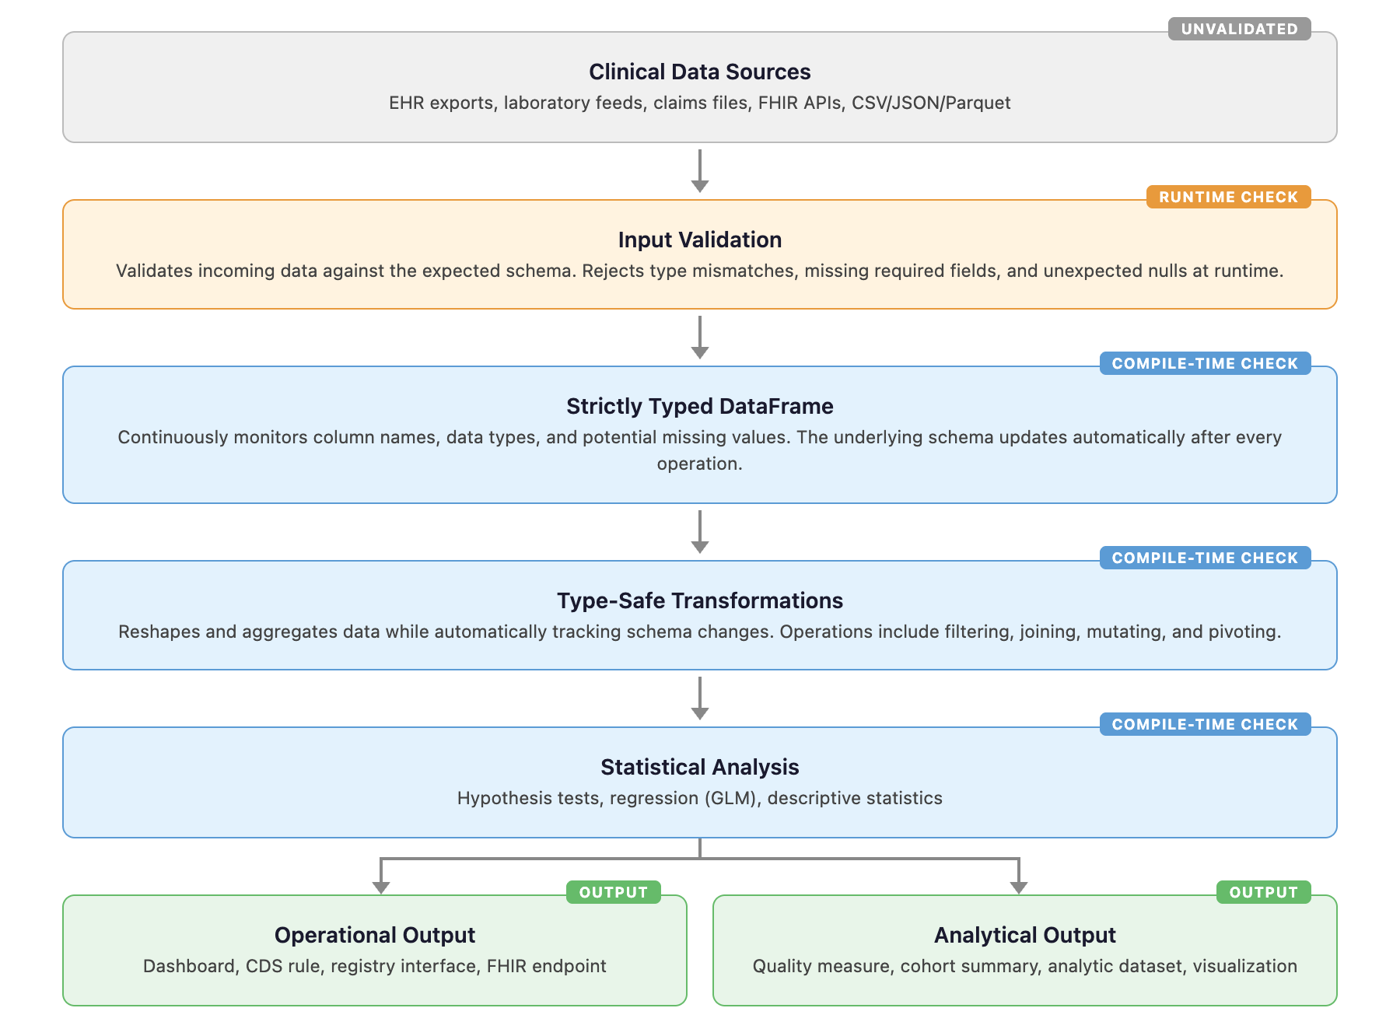

Figure 2. Error Detection Rates Across Analytical Frameworks

A heatmap comparing the proportion of simulated data analytics errors (n=65) that halt code execution in Baseline, Python (pandas), and R (tidyverse). Baseline successfully intercepted 100% of errors across all categories, whereas conventional frameworks demonstrated a severe detection gap regarding null and missing data.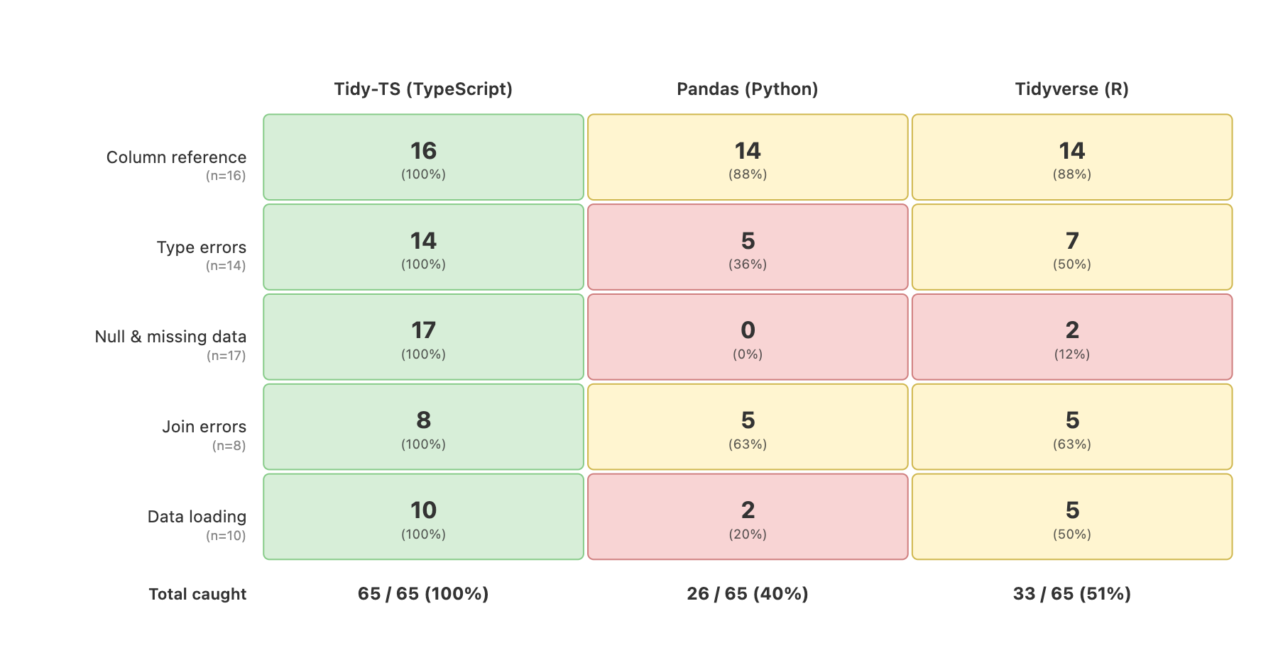

Figure 3. Example Comparison of Error Detection Between Frameworks.

When attempting to multiply a column containing a text value ("MISSING"), the frameworks exhibit three distinct behaviors. Baseline detects the invalid operation and highlights the error before execution. Pandas executes silently, propagating a logical error by repeating the string ("MISSINGMISSING"). Tidyverse halts at runtime with an error.

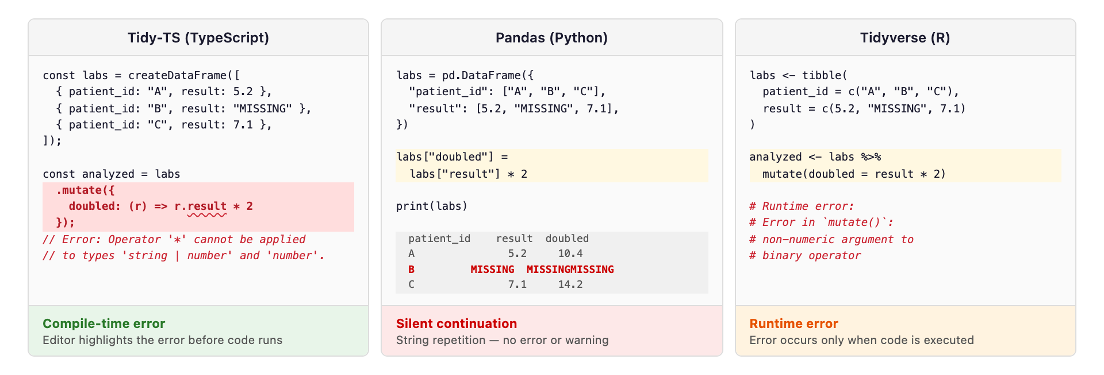

Table 1. Detection Outcomes by Error Category.
Detection outcomes across 65 simulated error scenarios. For Baseline, the 'compile' column indicates errors successfully intercepted before execution, while the 'If bypassed' column indicates errors that would still trigger a runtime halt if static typing checks were explicitly overridden by the analyst.
 |  |  | Baseline (TypeScript) |  | Pandas (Python) |  |  | Tidyverse (R)
 |  |  | compile | If bypassed | runtime |  |  | runtime
Category | Example error | n | error | error | error | warn | silent | error | warn | silent
Column reference | Use ‘patientId’ instead of ‘patient_id’ | 16 | 16 | 16 | 14 | 0 | 2 | 14 | 0 | 2
Value type errors | Including written text in an arithmetic operation | 14 | 13 | 3 | 5 | 0 | 9 | 4 | 3 | 7
Missing value errors | Divide by a reference range value that may be missing | 17 | 17 | 3 | 0 | 0 | 17 | 2 | 0 | 15
Join errors | Use a department column that may be missing after joining patients to encounters | 8 | 8 | 6 | 5 | 0 | 3 | 5 | 0 | 3
Data loading | Load lab results expecting numeric data, but receiving a text entry like "pending" | 10 | 8 | 8 | 2 | 0 | 8 | 4 | 1 | 5
Total |  | 65 | 62 | 36 | 26 | 0 | 39 | 29 | 4 | 32

Supplemental Table 1: Type Rules in Baseline data frames

Let 𝜌 denote a row type (i.e., a mapping from column names to types).

For a set of columns $C$:

$ρ[C]$ denotes projection onto $C$,

$ρ∖C$ denotes removal of columns in $C$,

$ρ∪S$ denotes schema union, assuming disjoint column names or an explicitly specified collision-resolution policy

$T ∣ ⊥$ denotes an optional value of type $T$, where $⊥$ corresponds to an absent or undefined value.

Lowercase identifiers $a, b, c, k, n, v$, and $t$ range over column names.

For joins, $L$ and $R$ denote the left and right input schemas, respectively, and $K$ denotes the join key set.

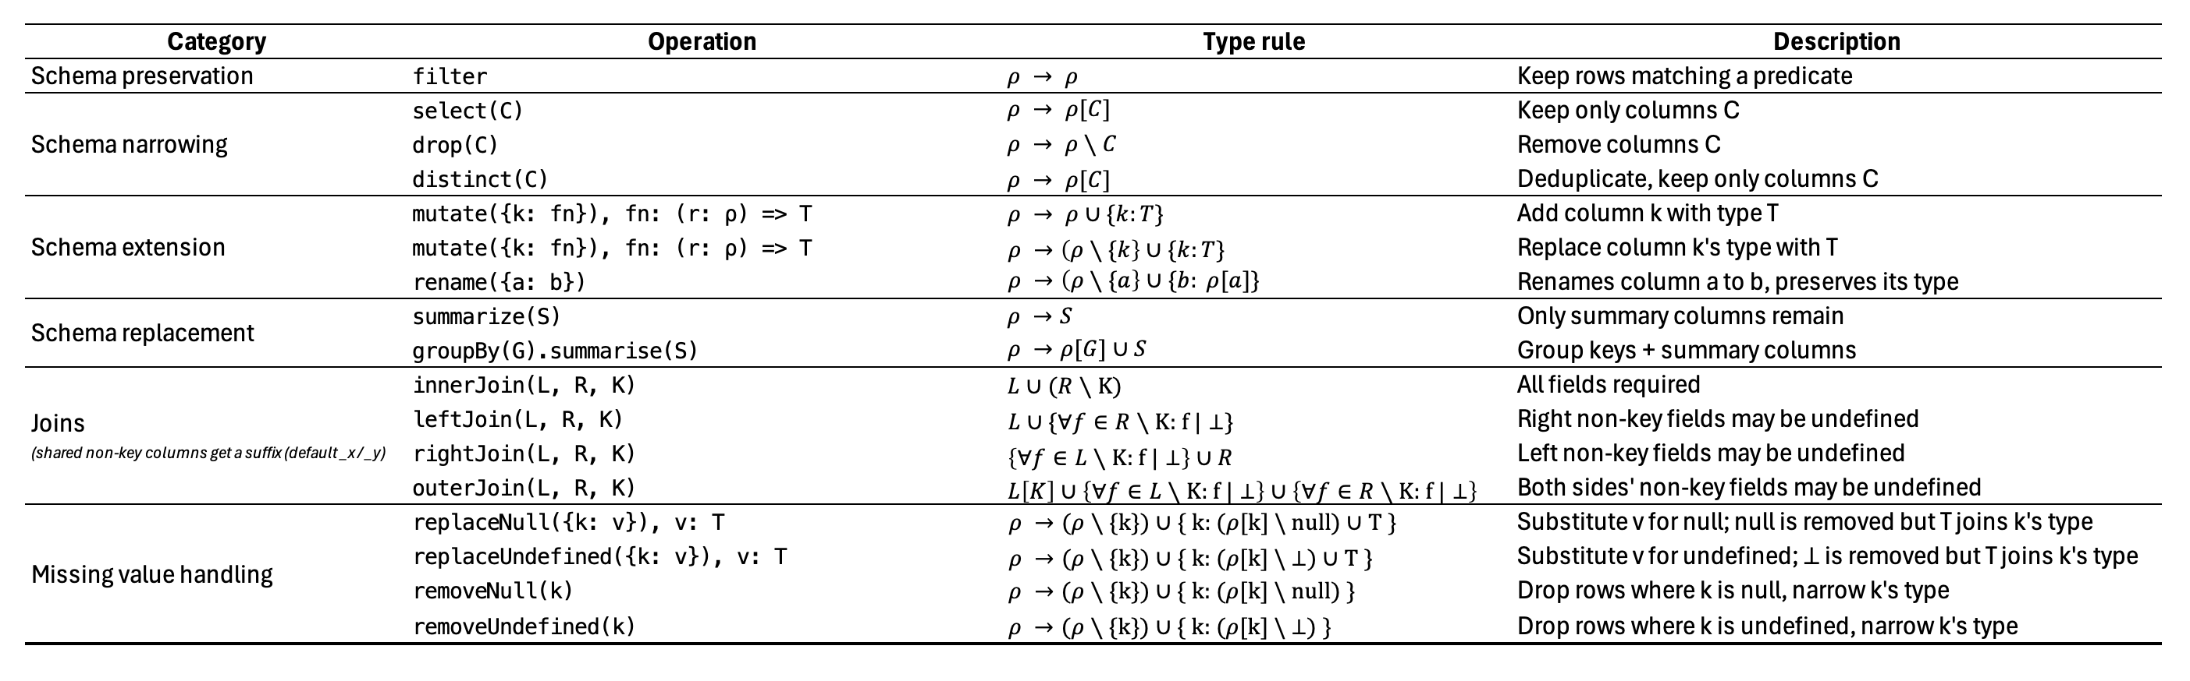

Supplemental Table 2. Detection Outcomes by Error Category, including Python Static Type Checker Coverage and Polars.
Detection outcomes for pyright (1.1.400) and mypy (1.16.0) running in strict mode on the same 65 error scenarios, with pandas-stubs (2.2.3.241126) installed. Polars (1.30.0) runtime results are included for comparison.
 |  | Baseline |  | pyright | mypy | Polars | pandas | tidyverse
Category | n | compile | If bypassed | compile | compile | runtime | runtime | runtime
Column reference | 16 | 16 (100%) | 16 (100%) | 0 (0%) | 0 (0%) | 14 (88%) | 14 (88%) | 14 (88%)
Value type | 14 | 13 (93%) | 3 (21%) | 0 (0%) | 1 (7%) | 6 (43%) | 5 (36%) | 4 (29%)
Missing value | 17 | 17 (100%) | 3 (18%) | 0 (0%) | 0 (0%) | 0 (0%) | 0 (0%) | 2 (12%)
Join errors | 8 | 8 (100%) | 6 (75%) | 0 (0%) | 0 (0%) | 3 (38%) | 5 (63%) | 5 (63%)
Data loading | 10 | 8 (80%) | 8 (80%) | 0 (0%) | 0 (0%) | 5 (50%) | 2 (20%) | 5 (50%)
Total | 65 | 62 (95%) | 36 (55%) | 0 (0%) | 1 (2%) | 28 (43%) | 26 (40%) | 29 (45%)

Supplemental Table 3. Rationale for Exclusion of External Bugs from Framework Comparison

The table below captures the reasoning for excluding bugs from the external collection when evaluating Baseline, Python (pandas), and R (tidyverse).

